Read chapter 9 the topic we have already discussed. Answer the following on a full-scape sheet. After completing the assignment turning in homework with images is mandatory.
Q1. Keeping in mind reflection and refraction. Explain what is shown in the following image.
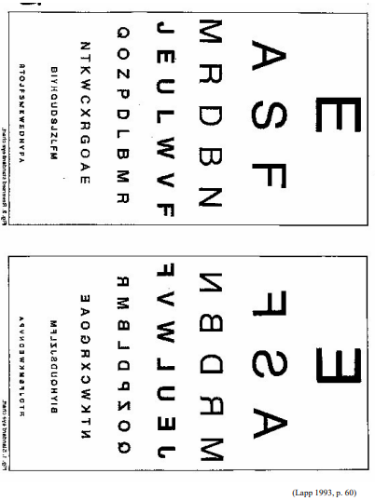
Q2. Can you identify any application of the scenario you have explained in Q1.
Q3. Define refractive index with its formula.
Reference chapter 9 of book international secondary science
Q4. watching the following video https://youtube.com/shorts/L-avd0nMeYw?si=Ytq3pr7xspbxfNl9
Describe what happens to the Pyrex beaker when the jug is placed in liquid. At what moment does the beaker seem to disappear? Explain your reasoning.
(Pyrex is a type of glass)
Q5. Can you think of another real-life application where matching refractive indices is useful?.
Q6. Observe the image of the sun rising amid smog and air pollution on a morning in Karachi, Pakistan, November 14, 2024.
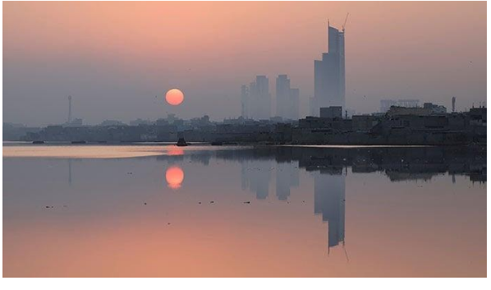
a) What kind of reflection we can see in water?
b) Justify: Water behaves as a mirror
c) Justify: Water is NOT behaving as a mirror
d) What difference can you see in the object and reflection?
e) Why is the reflection of the Sun dimmer than the object?

